UNIT-3
System Model
A system can be modeled as a collection of limited resources, which can be partitioned into different categories, to be allocated to a number of processes, each having different needs. Resource categories may include memory, printers, CPUs, open files, tape drives, CD-ROMS, etc. Some categories may have a single resource.
In normal operation a process must request a resource before using it, and release it when it is done, in the following sequence:
- Request - If the request cannot be immediately granted, then the process must wait until the resource(s) it needs become available. For example the system calls open( ), malloc( ), new( ), and request( ).
- Use - The process uses the resource, e.g. prints to the printer or reads from the file.
- Release - The process relinquishes the resource. so that it becomes available for other processes. For example, close( ), free( ), delete( ), and release( ).
A set of processes is deadlocked when every process in the set is waiting for a resource that is currently allocated to another process in the set (and which can only be released when that other waiting process makes progress. )
Deadlock is a situation where a set of processes are blocked because each process is holding a resource and waiting for another resource acquired by some other process.
Consider an example when two trains are coming toward each other on same track and there is only one track, none of the trains can move once they are in front of each other. Similar situation occurs in operating systems when there are two or more processes hold some resources and wait for resources held by other(s). For example, in the below diagram, Process 1 is holding Resource 1 and waiting for resource 2 which is acquired by process 2, and process 2 is waiting for resource 1.
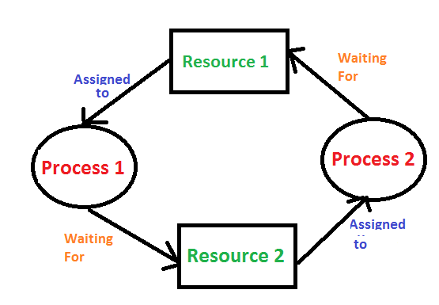

Necessary Conditions
There are four conditions that are necessary to achieve deadlock:
- Mutual Exclusion - At least one resource must be held in a non-sharable mode; If any other process requests this resource, then that process must wait for the resource to be released.
- Hold and Wait - A process must be simultaneously holding at least one resource and waiting for at least one resource that is currently being held by some other process.
- No preemption - Once a process is holding a resource ( i.e. once its request has been granted ), then that resource cannot be taken away from that process until the process voluntarily releases it.
- Circular Wait - A set of processes { P₀, P₁, P₂, . . ., P_{N} } must exist such that every P[ i ] is waiting for P[ ( i + 1 ) % ( N + 1 ) ].

Resource-Allocation Graph In some cases deadlocks can be understood more clearly through the use of Resource-Allocation Graphs, having the following properties:
A set of resource categories, { R₁, R₂, R₃, . . ., R_{N} }, which appear as square nodes on the graph. Dots inside the resource nodes indicate specific instances of the resource. ( E.g. two dots might represent two laser printers. )
A set of processes, { P₁, P₂, P₃, . . ., P_{N} }
Request Edges - A set of directed arcs from P_{i} to Rj, indicating that process Pi has requested Rj, and is currently waiting for that resource to become available.
Assignment Edges - A set of directed arcs from Rj to Pi indicating that resource Rj has been allocated to process Pi, and that Pi is currently holding resource Rj.
Note that a request edge can be converted into an assignment edge by reversing the direction of the arc when the request is granted. For example:
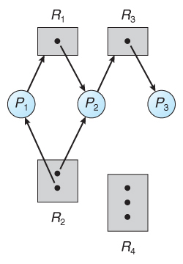
Figure : Resource allocation graph
- If a resource-allocation graph contains no cycles, then the system is not deadlocked. If a resource-allocation graph does contain cycles AND each resource category contains only a single instance, then a deadlock exists.
- If a resource category contains more than one instance, then the presence of a cycle in the resource-allocation graph indicates the possibility of a deadlock, but does not guarantee one. Consider, for example,
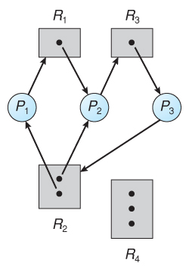
Figure : Resource allocation graph with a deadlock
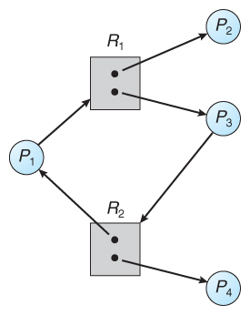
Figure - Resource allocation graph with a cycle but no deadlock

Methods for Handling Deadlocks
Generally speaking there are three ways of handling deadlocks:
- Deadlock prevention or avoidance-Do not allow system to get into a deadlocked state.
- Deadlock detection and recovery - Abort a process or preempt some resources when deadlocks are detected.
- Ignore the problem all together - If deadlocks only occur once a year or so, it may be better to simply let them happen and reboot as necessary than to incur the constant overhead and system performance penalties associated with deadlock prevention or detection. This is the approach that both Windows and UNIX take.
In order to avoid deadlocks, the system must have additional information about all processes. In particular, the system must know what resources a process may request in future. Deadlock detection is fairly straightforward, but deadlock recovery requires either aborting processes or preempting resources, neither of which is an attractive alternative.
- If deadlocks are neither prevented nor detected, then when a deadlock occurs the system will gradually slow down, as more and more processes become stuck waiting for resources currently held by the deadlock and by other waiting processes.

